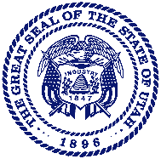
Department of Public Safety

JESS L. ANDERSON
Commissioner

State of Utah
TED BLACK
State Fire Marshal

SPENCER J. COX
Governor

DEIDRE M. HENDERSON
Lieutenant Governor

October 30, 2023

To: All Fireworks Operators/Artists and Companies
Effective: January 1, 2024

As of December 31, 2023, your license will be expired. To maintain current licensing, please renew before December 31.

All renewals for the coming year must be received before May 17, 2024. Renewals and testing will not be offered from May 17 – July 31, 2024. There will be no exceptions.

For new applicants, please plan accordingly with training and safety courses so individuals meet all requirements before testing. Testing must be scheduled due to limited seating available. Tests are offered on Tuesday mornings at 8am (with appointment). Other arrangements can be made based upon availability of our staff. We will do our best to accommodate everyone.

Please contact me at (801) 386-0570 or fireworks@utah.gov if you have any questions or if I can be of assistance to you.

Respectfully,

Nia Kekauoha

Fireworks Program Manager

