QUICK GLANCE

FIRE PREVENTION WEEK – Utah State Fire Marshal’s Office

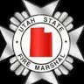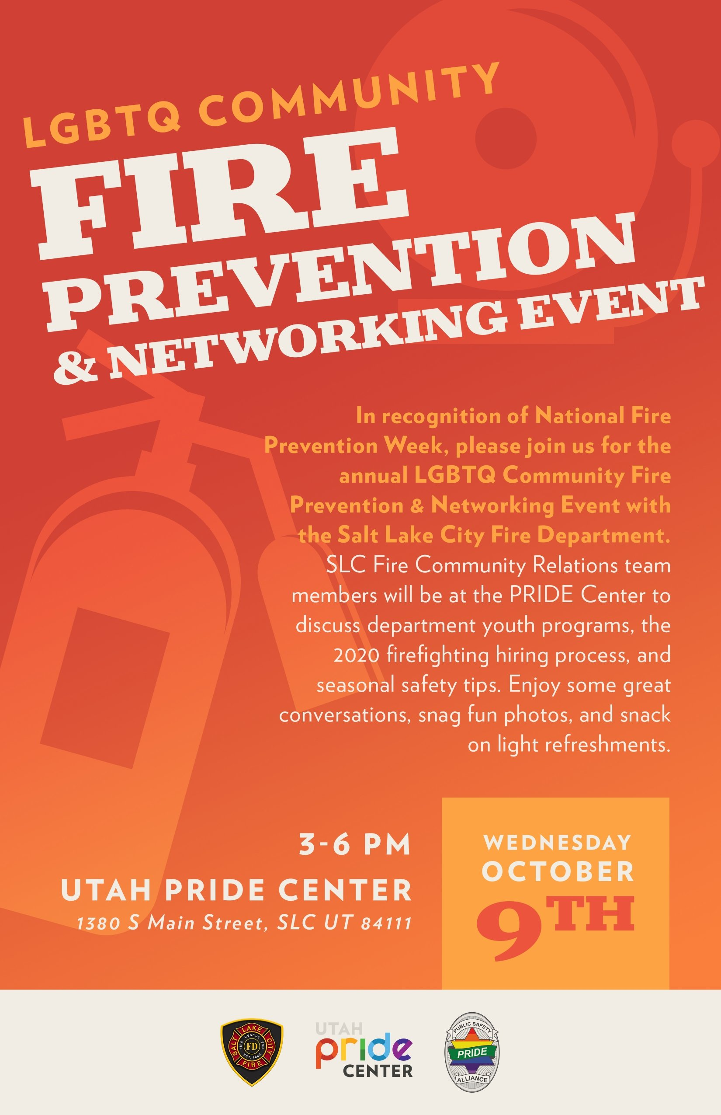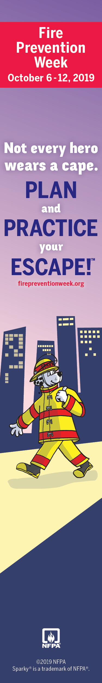

State Fire Marshal’s Office operates 8 Fire Safety Trailers statewide
Trailers served at over 60 appointments at events, school programs, department open houses, hospitals, church events, and more.
Events host anywhere from 200-1500 people
School events average 700-1000 students
Approximately 30,000 students went through our trailers
We estimate 80,000 Utahns received some sort of direct fire education this month

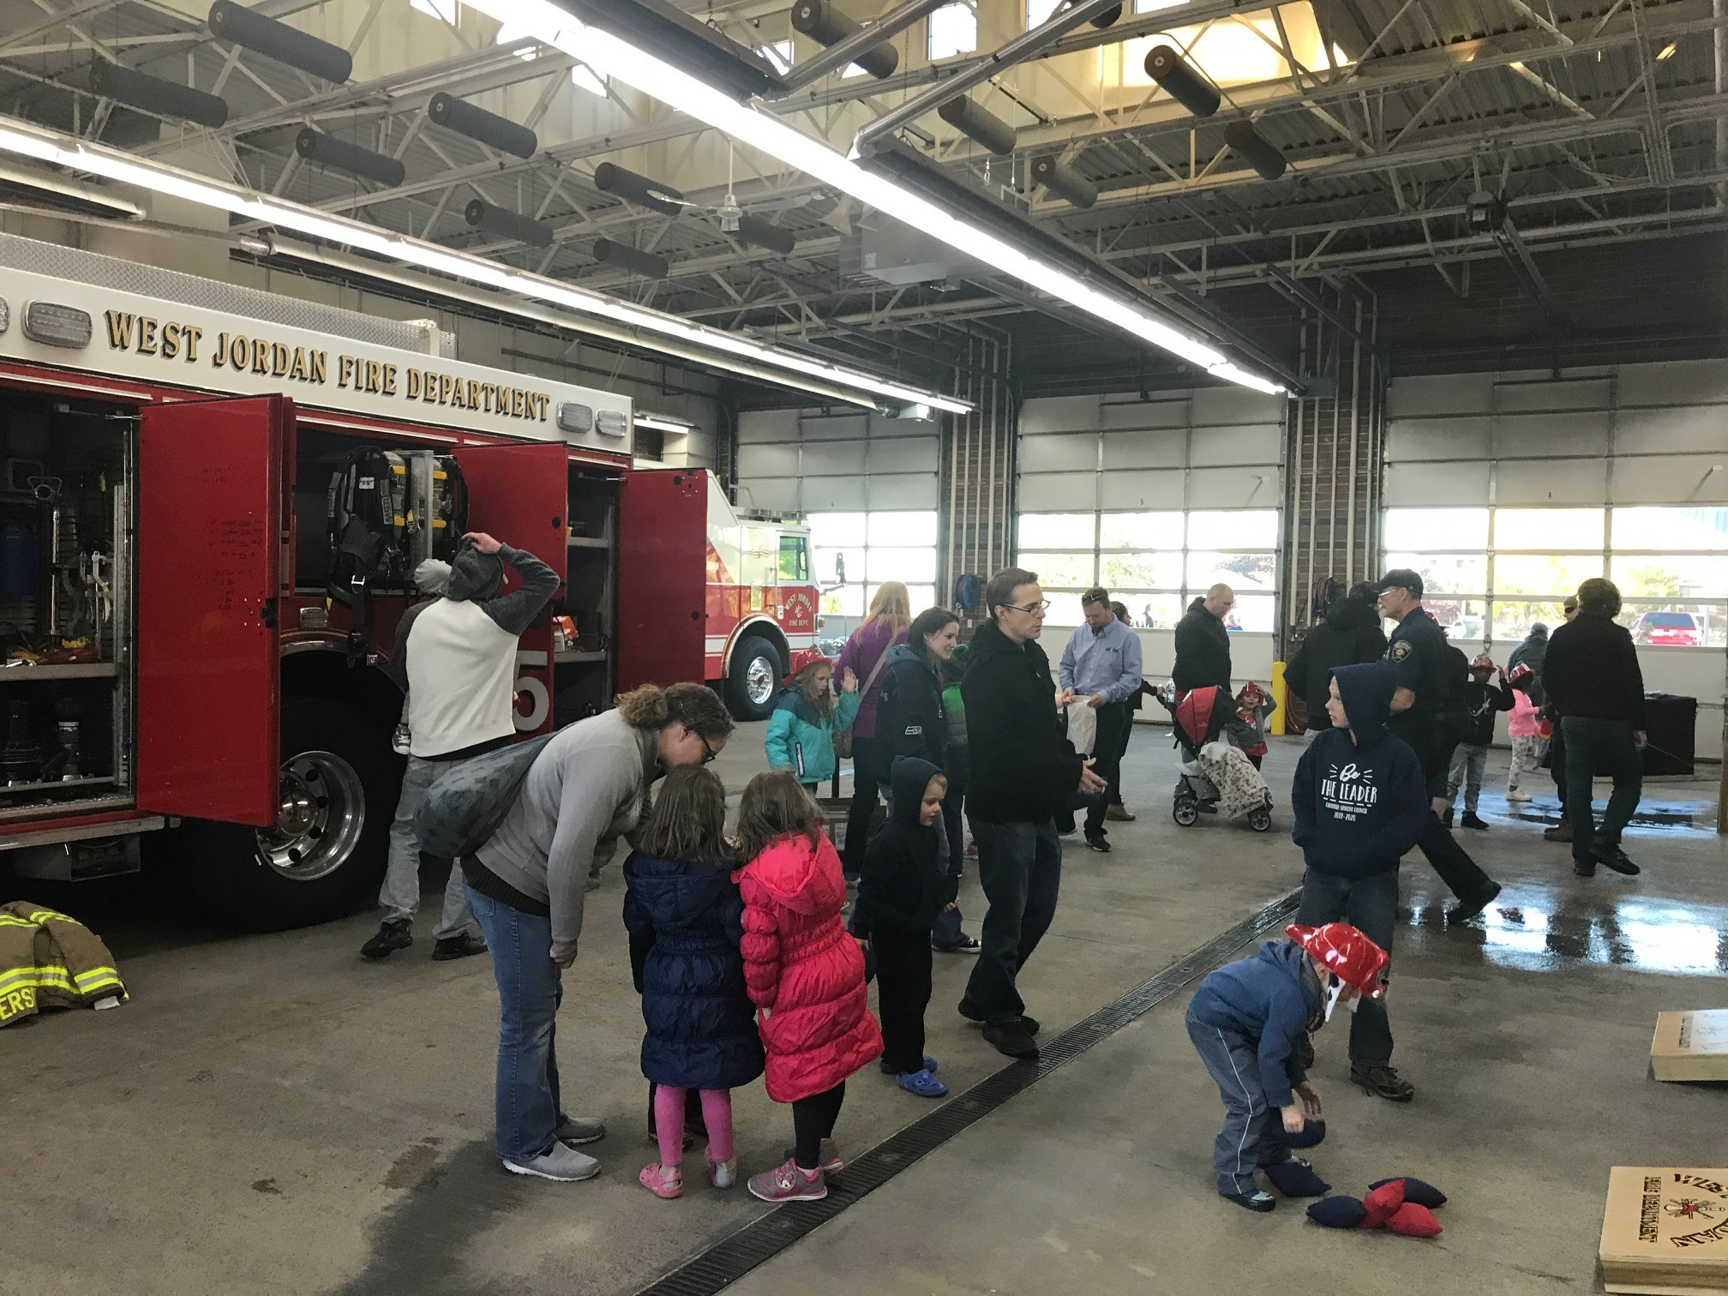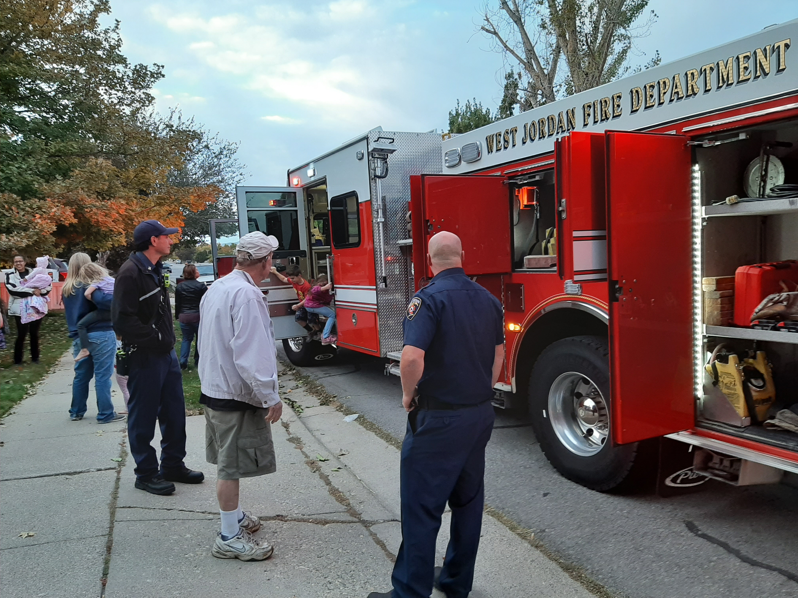
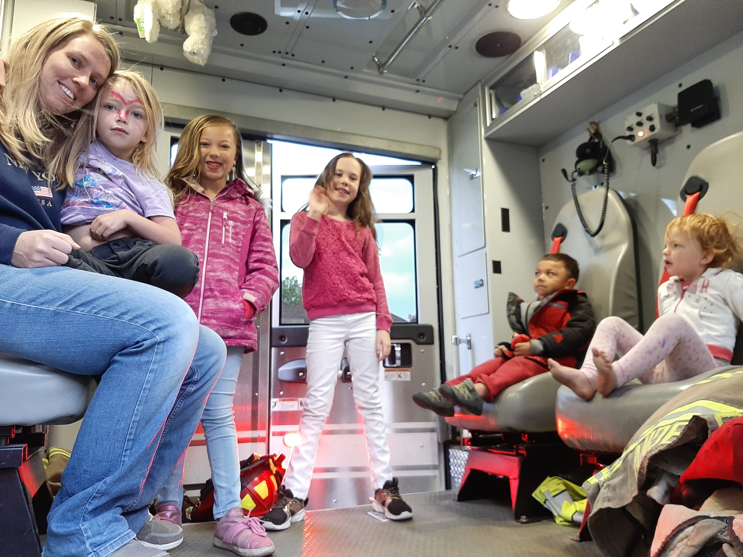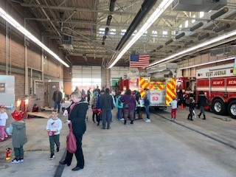
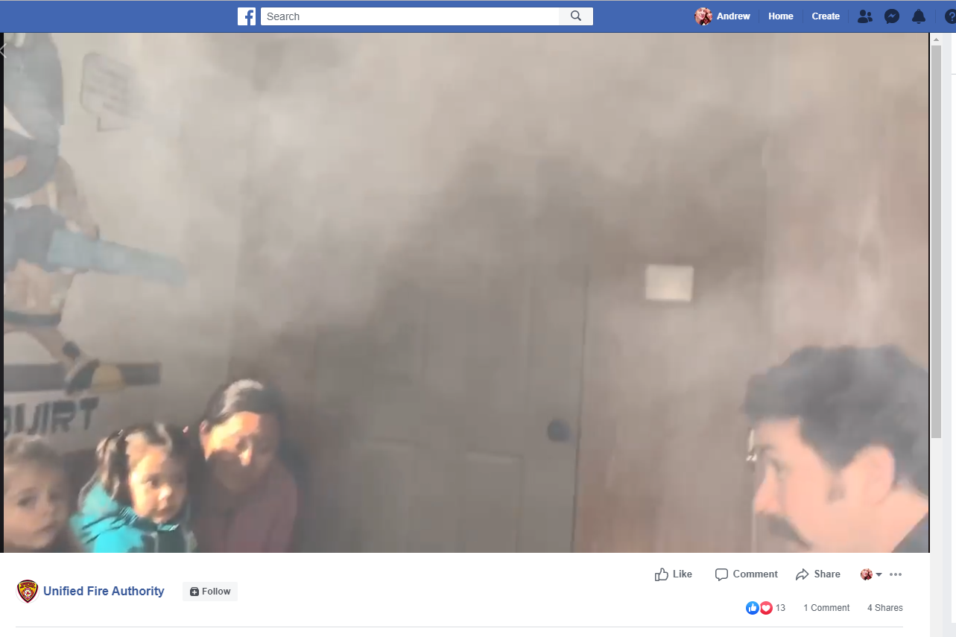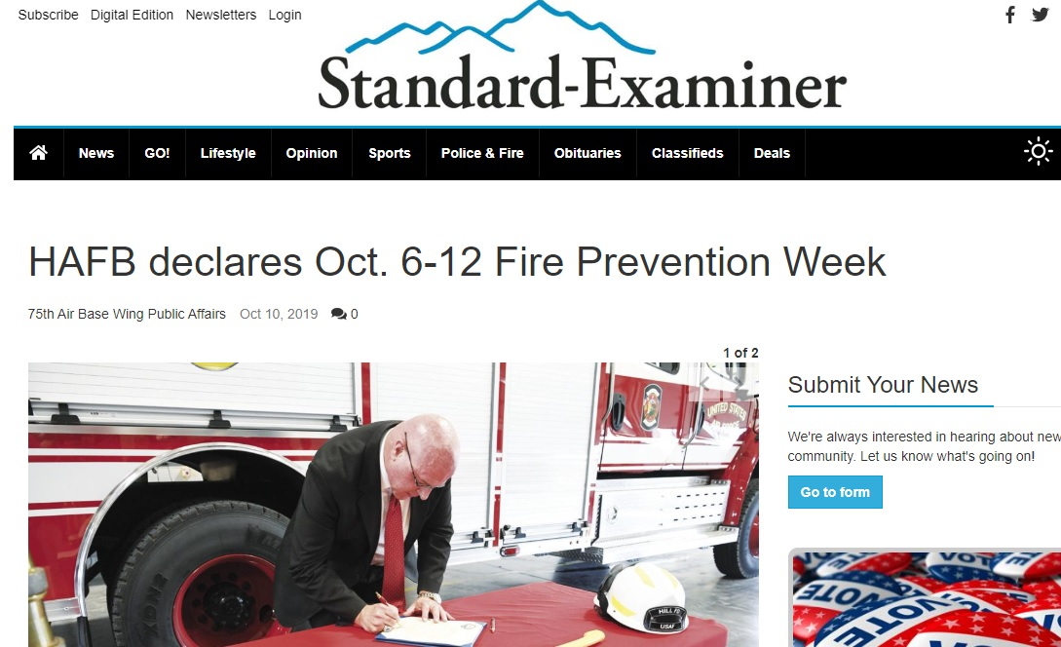

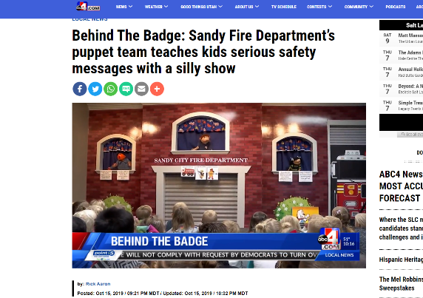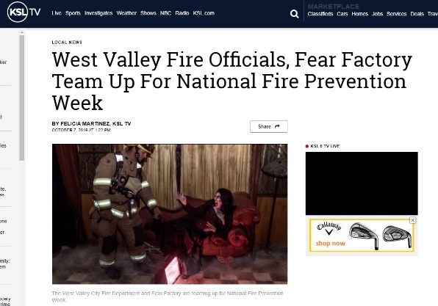
Notes:
Its sometimes difficult to quantify the amount of successes throughout the state, but we can report on the qualifiable information we’ve received from some of the departments that reported into the State Fire Marshal’s.
Our office loans out 8 Fire Safety Trailers to departments throughout the state. Rural, suburban, and urban areas all utilize the trailers.
In October, our trailers were requested for use at over 40 events state wide. Some were multiple events held over several days, so it’s likely its more than double that number. We estimate that over 80,000 people went through our trailers during Fire Prevention Month.
I asked for reports from departments and heard back from quite a few. Some notable stand outs I’d like to thank for their hard work and efforts are Logan Fire, Unified Fire, Sandy Fire, and West Jordan Fire, just to name a few. I appreciate these and other departments taking the time to report to me with detailed notes.
Logan Fire made the effort to take our trailer to every elementary school in their district to provide Fire Safety Education to every student, K through 6th. They also held daily open houses for child care and pre-schools to visit the fire houses. They spread Fire Prevention Week all the way into November to complete this mission.
Sandy Fire also tried to teach at every elementary school this month. They got some great press for their safety puppet show geared towards preschoolers. Sandy estimates that over 500 3-4 year olds were taught during the month of October.
West Jordan Fire had the novel approach to work with Dominos Pizza in their efforts to education the public on the importance of working fire alarms. Firefighters helped deliver the pizza to costumers, and if the firefighter tested and determined that the smoke detector in the home worked, the pizza was free. They held a drawing contest in local schools and held a city-wide safety scavenger hunt. These are really creative ways to engage the community.
Unified Fire has cracked the code for online, social media safety programming. They regularly received hundreds of hits per day on their safety education posts, including videos, memes, pictures, safety messages and more. They consolidated their efforts into one video, which can be found here: https://www.facebook.com/unifiedfireauthority/videos/452585095356481/

